
Project Manager:
1. Enaida Bejdić

Date: 04 January 2019
project:
human resources database design

electronic archive of business documentation

PROJECT FORMAT

PROJECT NAME: | Electronic archive  of business documentation in Human Resources department

PROJECT LEADER: | Employee of the Human Resources department

PROJECT ASSOCIATES: | An employee of IT department

TARGET GROUP: | Employees in the Human Resources Department, New Hires

LOCATION: | Tuzla

PROJECT DURATION: | 36 working days

BUDGET: | 24480 KM

SUMMARY
The goal of this project was to improve the efficiency of the company's operations by reducing errors, loss of time and to improve the quality of reporting in Human Resources department. It was necessary to raise the level of department productivity in the recruitment process. This was achieved by designing and implementing a single centralized relational database to replace the diverse data silos scattered in various locations and formats within department.
A centralized database eliminates the redundancy and inconsistency of data, directly affecting the exponential increase in reporting quality. Such data reflect the accurate and realistic state of the department and the entire company from the aspect of human resources. As for the reports, the most important are metric reports of HR, in which the activities of the department are expressed statistically, quantitatively, graphically and tabularly. Such reports, based on real facts, go to senior management which they use them for further business decisions. Therefore, it is very likely that senior management will make good business decisions, realistic forecasts and predictions of future activities. It is one of the most important bases for the expansion, development and progress of the company in general.
The work on the database was taken over by me, as an employee of the Human Resources Department. The first phase of development, determining user requirements, was practically eliminated, because as a member of the HR team I was completely clear about the need to develop such a database. The business process of the department and the company itself was also clear to me, as I had been with the company from the very beginning. I had the skills to design a database, which means that the software was developed internally. It was decided to use SQL Server for the backend, and to keep the frontend in MS Access. The relevant database could have been developed in already existing information system architecture, with client computers being replaced by stronger computers higher performances. The "price" of developing this application was my withdrawal from other HR activities and their transfer to other team members.
To achieve the goal of this project, the activities, detail described in paragraph 3. Project description, have been undertaken.
Collaborators in this project were the staff of the IT department in charge of procurement and installation of new computers and network connections, and an external consultant who gave his opinion on the design and type of software to be used. All aspects of application development were done by me independently. I had assigned computer available for development and my time was also allocated to this project.
There were two direct target groups of this project. Primary staff of the HR department in order to achieve better results, and the second one was group of new hires whose satisfaction with the hiring process as a first impression of the company was of great importance.
The project activities lasted 36 working days, with the time limit remaining open for the processes of scanning paper documents with signatures and stamps - so that they could be digitized as well.

1. INFORMATION ABOUT THE PROJECT HOLDER(S)

The project holder was me, an employee in HR department. At that time I was an HR Generalist with many years of experience. The most important competencies in this case were my skills in relational database design, good knowledge of business processes, company policy, orientation, goals and mission. Developer by profession.

2. INTRODUCTION / DESCRIPTION OF THE PROBLEM

In order to fully understand the problem this project solves, the following is a brief description of SOP for the employment process:

"The applicant is interested in the job and came to fill out the application. At the HR counter, he receives a form that he must fill out in order for his data to enter the database. After filling it out, HR Generalist enters the data into the database and the paper document goes to the files. When there is a need for employment or if new projects emerge, giving there are no potential internal transfers, HR staff selects candidates from the applicant database.
After selecting candidates, their personal data is checked in another database of people who have Inactive status, which means that they have already worked for the company in a certain period of time. This database is independent of the applicant database and is stored at another location. If these data show that, during any of his previous jobs, he had a clean file, meaning has not stopped working for bad reason such as theft, forgery of documents, causing an accident, attacking a work colleague, etc., the candidate is invited for an interview and testing.
If the candidate successfully passes a series of tests and interviews and is selected for an open position, the candidate submits the necessary documentation for employment: a certificate of impunity, diploma, certificates and an ID card or passport. If the documents are in order, the candidate signs the contract, his data is entered into the database of employees with Active status. His contract and other supporting documentation are placed in physical files and stored in file cabinets. The test results of non-employed candidates are also recorded, but remain in the applicant database for potential future calls.
When the number of employees in the company changes, various reports are generated: e.g. for HR management to monitor the development of the company in manpower and generate monthly metric reports or reports to the Finance Department for salary calculation.”

From this model, it is clear that employee data were located in three different locations: in the database of applicants, the database of active employees and in file cabinets. The redundancy and inconsistency of the data, mentioned in the Summary of this documentation, is obvious here: general data on one person should be entered only once: name, surname, address, occupation, date of birth, and all other data (applicant or active employee, test results, work history) should be linked to them.
In addition, there was another significant omission in the previous database design: it was designed to contain current status only, overriding the previous data when entering new data, thus losing insight into the history of the employee. Both databases were not based on a relational model, each had only one table, which made data manipulation even more difficult.

This means that, in order to achieve the ultimate goal of this project (quality of reporting), it was necessary to design a single database that will contain all the data about one person, from the moment he submits the job application, completes the test, signs the contract, department, pay rate, transfers, his work history, etc. until leaving firm including the time and reason for termination of employment. This was feasible by applying a relational design model including good design practice of normalization and optimization.

The amount of data that was transferred to the relational database was about 11.000 records of employees and about 20.000 records of applicants. The sum of megabytes of these databases to be integrated into a single database still did not not exceed the limit that Access itself could support, which at the time was 2 GB. Future possible base extensions have also been considered.

Therefore, the reliability of the system from the aspect of the application was ensured, and the downtime was predicted only in the event of a server crash, which was maintained by the IT department within the organization. MS Access was an integral part of the MS Office package installed on all new workstations of the Human Resources team and each of them had sufficient amount of RAM for smooth operation.
As it turned out later, the recruitment process was accelerated by a high percentage.

3. PROJECT DESCRIPTION

To achieve the goal of this project, the following activities have been undertaken:
- Design a single database by combining different formats (soft and hard copies).
- Procurement of SQL Server backend support.
- Database testing.
- Processes of technical education (handling the user interface of the database, getting acquainted with the structure and logic of data organization, a set of standard and desirable operations of the end user as, getting acquainted with the login, etc.).
- Connecting department sections. Having a single database means stronger connectivity of departmental sections: recruitment section, Active workers, Expats, HRIS (Human Resources Information Systems) and vacation planning section.
- A set of educational and informative workshops within HR (holistic approach to solving resistance to change: what to do if the system crashes, who to contact, training on data protection, rereading the policy of confidential data protection in HR department with all personal data, salary data, etc.).
- Organizing an additional meeting with management to practice transparency policy. Reputable companies have a practice of implementing a transparency policy that is very effective in the event of minor and especially major changes. Workers like to be informed by management about how to understand changes and why they are happening. This gives workers a sense of not “walking in the dark with their arms outstretched” and a sense of involvement and respect from management.

4. TARGET GROUP

There were two direct and one indirect target groups of this project.
The first group was HR staff in order to achieve better results by improving the information system, efficiency, productivity and to save time. Reports generated in HR reflected the real facts providing a good basis for management to take further steps.
The second group were clients. On one hand, new employees and their satisfaction with the hiring process. On the other hand, potential candidates interested in working in this company. At the same time, the new database also improved the customer service system.
The indirect group is senior management, which ultimately has the benefits of this project in terms of increasing profits.

5. OVERALL OBJECTIVE OF THE PROJECT

The overall objective of the project is to contribute to improving business efficiency by reducing errors, wasting time and improving the quality of reporting from the Human Resources department. Indicators of project success, like increase in profit by some percentage, could be found in the financial report (income statement), as well as on the official website of the company.
The underlying assumptions of this project were that the company continues to operate as planned, continuously, without unforeseen major changes such as closure, suspension, etc. The long-term benefit of the project, apart from the profit, was employee satisfaction.

6. SPECIFIC OBJECTIVES OF THE PROJECT

The specific goal of the project was the efficient and productive work of the Human Resources department in the recruitment process. Indicator of success was the acceleration of one person hiring process by 70%. This indicator was evident in monthly HR metric reports for senior management. Another, equally important indicator of the success of this project, was the better readiness of the HR department for auditing processes, which reflected the integrity of the HR in average.
Prerequisites for achieving this goal were trained workers to handle the database and behave in the event of a system crash. Another important assumption was that the functions of other HR sections (other than recruitment) remained unchanged or improved.

7. ACTIVITIES

An overview and description of the activities in achieving project goals is given in the following Gantt chart:

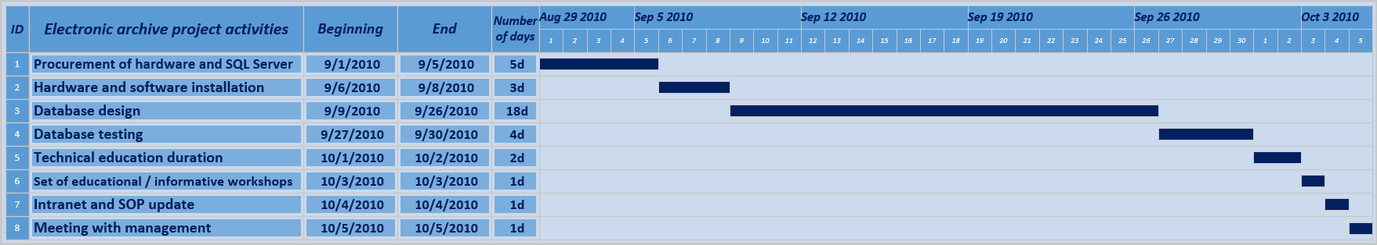

8. EXPECTED RESULTS

In this project, two expected results were:

1. Functional database installed
2. Employee resistance to change elimination

Success indicators: database installed for 8 HR employees on their workstations, reduced server memory and processor usage, reduced data flow through the network - possibility of congestion minimized, reduced number of complaints, increased level of satisfaction of new employees regarding the recruitment process.
All these indicators were registered in the reports of the HR and IT department and in the book of complaints / commendations. The preconditions for meeting these results were that employees remained employed in the company - turnover minimized, and the use of the database was included in the standard operating procedure of this department.

9. PROJECT DURATION

The project lasted 36 working days.

10. MONITORING, REPORTING AND EVALUATION

I administered evaluation, reporting and monitoring independently, in parallel with the development of the project. A total of four reports were recorded.

The first report was written on the eighth day of the project when the hardware and software were procured and installed. The report was an official confirmation that all the preconditions for starting the design of the database were met.
The second report was written in the middle of the design activity cycle, where it was noted that the development was going according to plan without deviations.
Completion of database design and testing was followed by a third report, which recorded a functional database ready for operational use.
The final report is written after the completion of the educational process and SOP update.

11. BUDGET

BUDGET OVERVIEW
Number | Category | Unit | Number of units | Unit price (KM) | Total  (KM)
1. | STAFF |  |  |  | 3300
1.1. | Database designer | day | 18 | 100 | 1800
1.2. | HR employee for database testing | day | 4 | 100 | 400
1.3. | Educator | day | 3 | 100 | 300
1.4. | Employee of IT department for procurement and installation of  hardware, software and network equipment | day | 8 | 100 | 800
2. | ADMINISTRATIVE EXPENSES
2.1. | Ignored (they are within the company)
2.2.
2.3.
2.4.
3. | OPERATING EXPENSES |  |  |  | 21180
3.1. | SQL Server | set | 1 | 3000 | 3000
3.2. | Computers | set | 8 | 2000 | 16000
3.3. | Network components | set | 1 | 1000 | 1000
3.4. | Consultant | day | 3 | 300 | 900
3.5. | Resources for breaks | set | 1 | 50 | 50
3.6. | Educational materials | set | 1 | 50 | 50
3.7. | Corporate level employee (update of Intranet and SOP) | day | 1 | 180 | 180
3.8.
3.9.
3.10.
TOTAL (KM) |  |  |  |  | 24480

Note: I worked for this company. And I designed this database, just not while I was working for the company, but after my employment. For the purpose of the courses of Project Management and Software Engineering I set it to be at the same time.

LIST OF ANNEXES

Annex 1 Logical framework matrix

Annex 2 Participation analysis

Annex 3 Problem analysis

Annex 4 Goal analysis

Annex 5 Project budget

Annex 6 Costs

Annex 7 Database design screenshots: The main form of HR database

Annex 8 Database design screenshots: Relationships in HR database

Annex 1

LOGICAL FRAMEWORK MATRIX

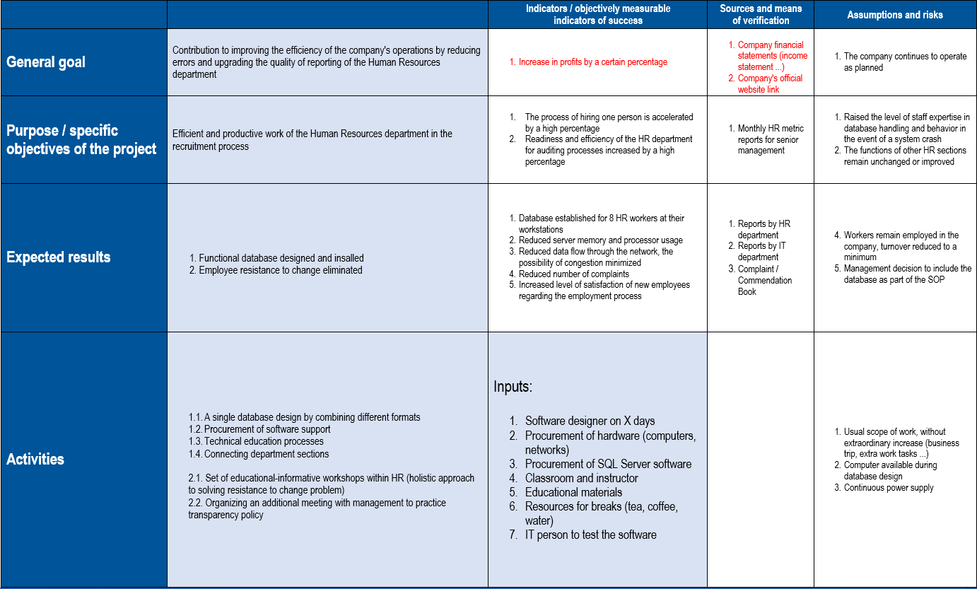
Annex 2

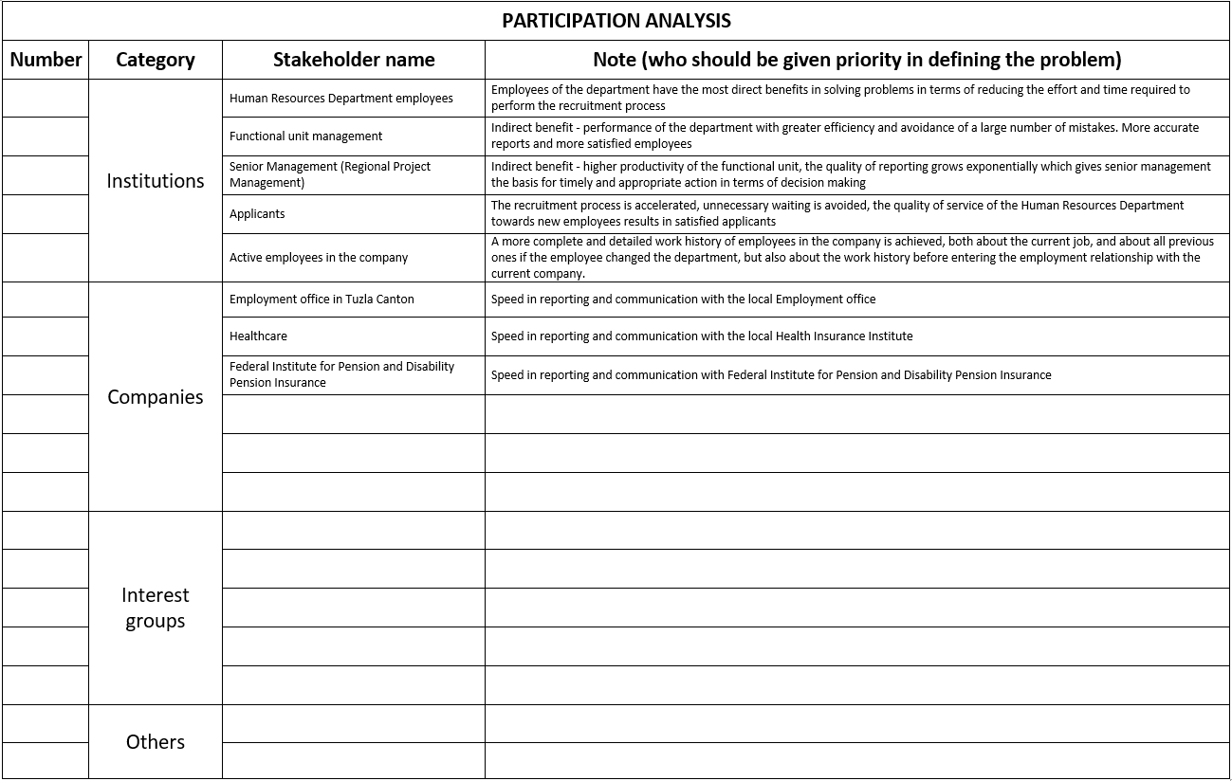

Annex 3

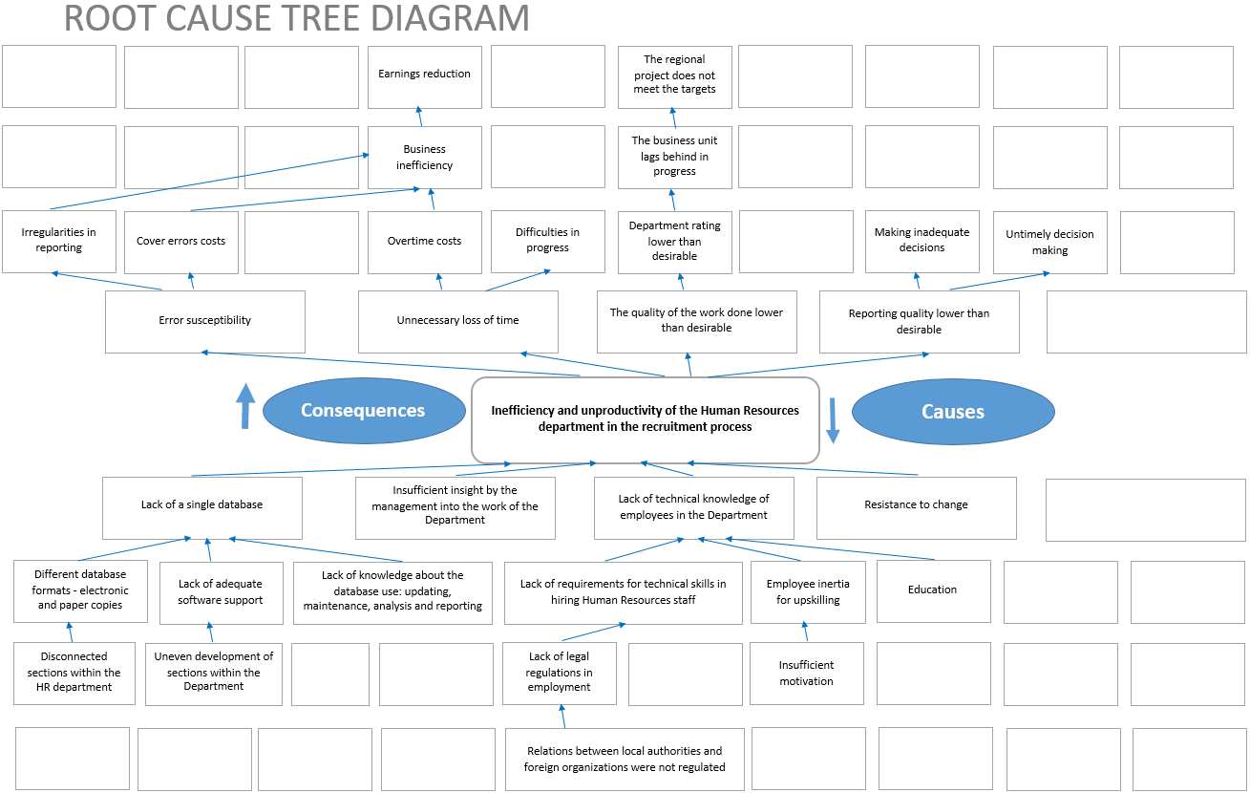

Annex 4

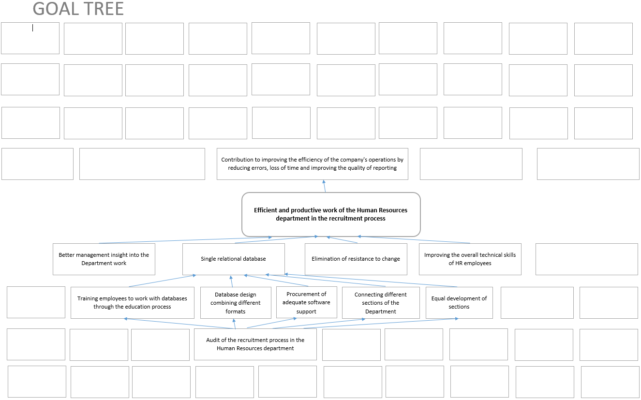

Annex 5

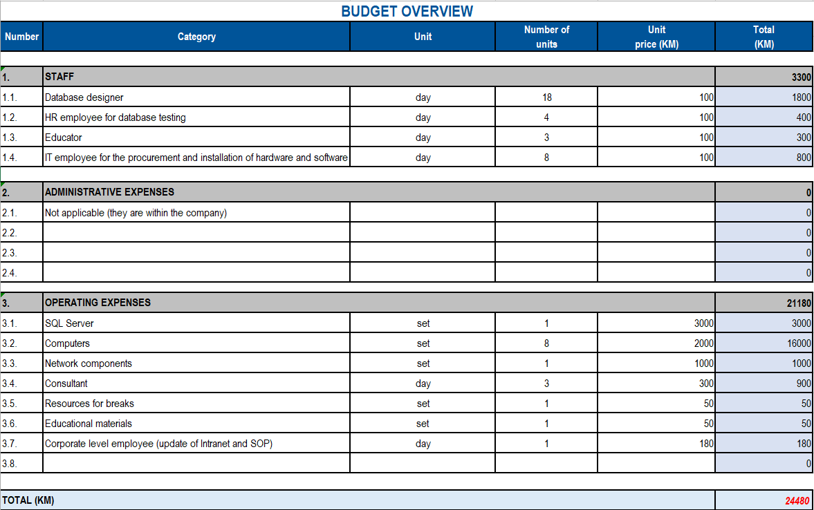

Annex 6

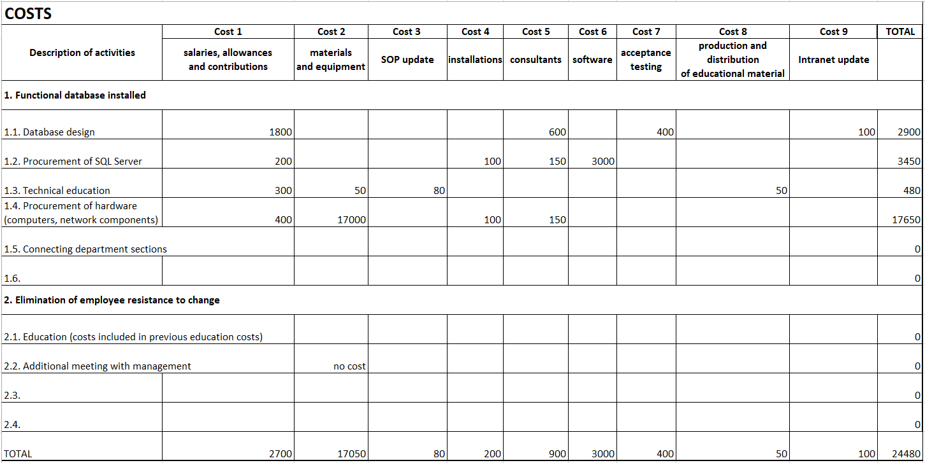
Annex 7

Database design screenshots: The main form of HR database

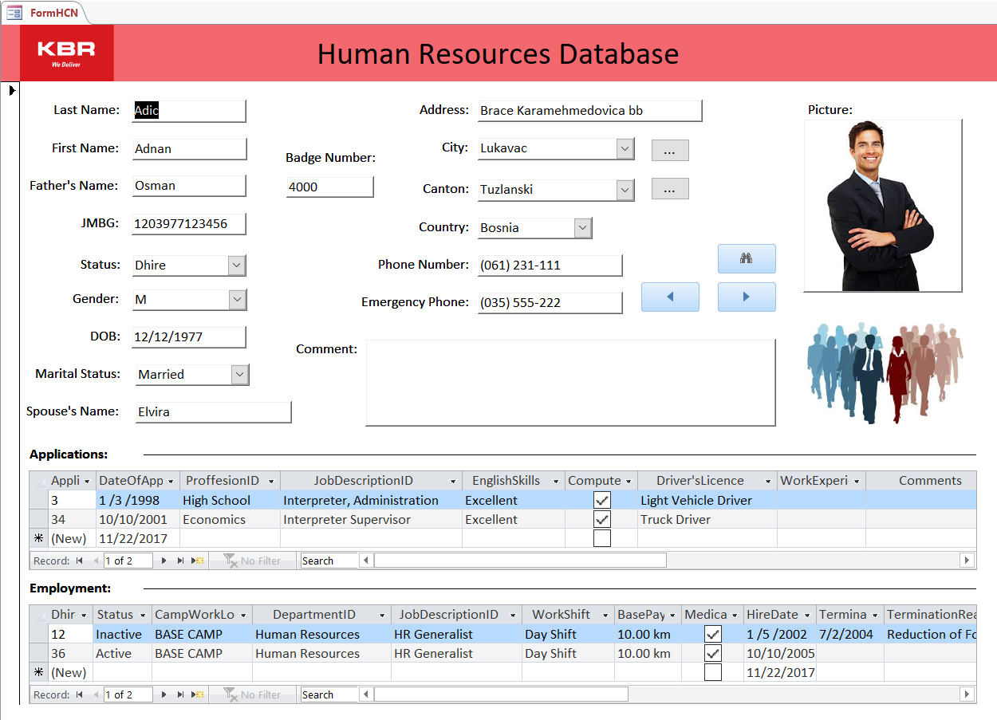

Annex 7

Database design screenshots: Relationships in HR database

